CONTENT GUIDE

Domestic Uniform Rental
Responsive Website Conversion

September 1, 2017

The Importance of Writing Dynamic Website Copy

Your web copy needs to consider your target audiences, the devices they use, and the computer algorisms that power their search engines. While search engines, such as Google, have become better at recognizing content written for people, site code designed to speak with search engines is still necessary for an optimum search rank. However, the best Search Engine Optimization (SEO) comes from providing users with a good experience.

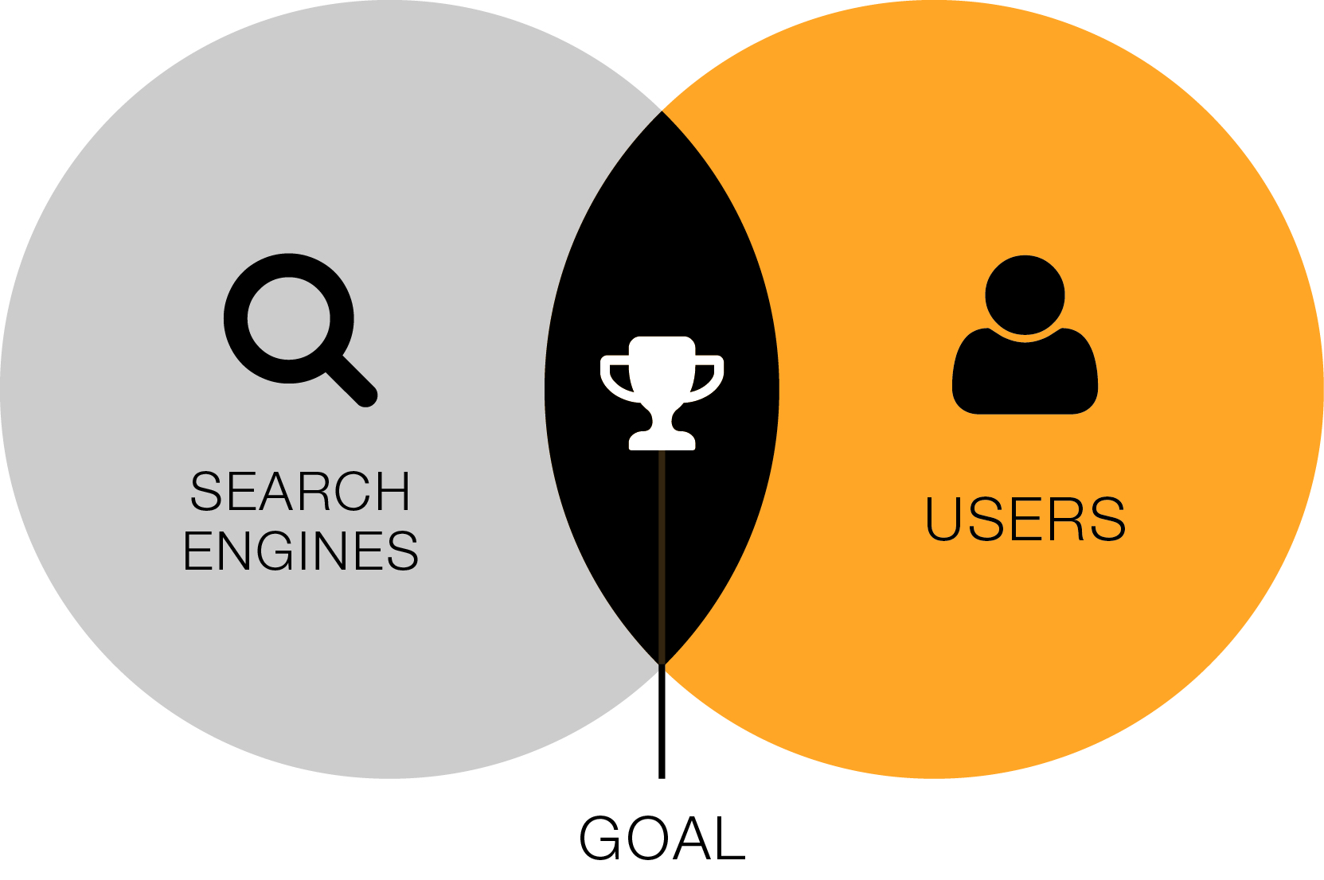
How to Target Both Users and Search Engines
- Use 300 words or less on most pages
(some types of pages warrant more content)
- Provide a clear path of action to direct users to more substantial information
- Keep text clean and uncomplicated
- Content should be composed of three to five elements, such as:
  - Paragraphs
  - Images
  - Grouping of bullets

Tips for Success
- Be Consistent – Since content can come from many sources, make sure to have a point person review all copy to ensure consistency in tone, length of copy, and so on.
- Remember Your Audience(s) – Messages that are of interest to the target audience are most effective. Also, remember that different pages may address different audiences.
- Use Calls to Action – Calls to action are critical because they inform and direct your users to important information or actions on the website.
For example: “If you’re interested in a customized Content Management System (CMS), please contact us at (248) 687-7888 or inquiry@mediaG.com.”
- Less Is More – Using bullets in place of copy and descriptive headers wherever possible helps increase a users understanding of the content, and achieves better results compared to lengthy descriptions.
- Remember Learning Styles – Pull quotes, highlighted areas, bold text, and graphics increases the appeal of your site to a broader spectrum of individuals and increases understanding among different learning styles.

Metadata
All metadata should be relevant to the page content.

Title
The title is the name of each page that appears in the top bar of your internet browser and in the search engine results. Ideally, these are fewer than 65 characters (including spaces).

Description
The description appears on the search engine results page below the website’s URL and Title.
The description tag offers an opportunity to advertise the value of the page and encourage people to click. Avoid supplying information that is redundant with your title tag to allow more space for persuasive content. The description is one to two unique sentences per webpage and describes the content of the page. Ideally, these are fewer than 160 characters (including spaces).

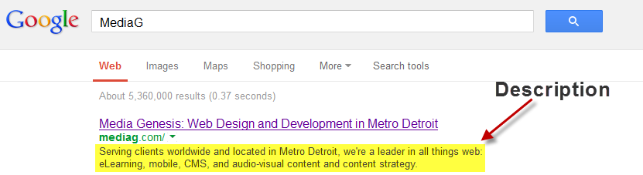

Keywords
Include five to ten keywords or key phrases that are relevant to the content of the page. These words and/or phrases have to appear in the content of the page. If the search engine robots pick notice keywords that do not appear in your content, your site may be ranked down.

Example Content Box

MG Sitemap  Page # and Title | 0.0 Home
SEO Title | Website Design and Development in Metro Detroit | Media Genesis
Description | Serving clients worldwide and located in Metro Detroit, we’re a leader in all things web: eLearning, mobile, CMS, and audio-visual content and content strategy.
Keywords | web development, social media, graphic design, elearning, southeast michigan
Actual Text | Design  Deliver a compelling first impression and a clear course of action. When we create a design for you, we don’t work in a vacuum. Our designers use deep knowledge of your brand identity, your audience, and best practices. We offer logo development, print collateral design, web design, and application design that make a lasting impression and increase usability and usefulness.
Images  Please reference  file names, when possible | MediaG_logo_b&w_082617
Links | The Media Genesis Facebook link: https://www.facebook.com/MediaGenesis

Client Name Content

MG Sitemap  Page # and Title | 0.0 Home
SEO Title | Uniform Rental and Facility Services | Domestic Uniform Rental
Description | Keeping the American Workplace Dressed for Over 90 Years
Keywords
Actual Text
Images  Please reference  file names, when possible | Chris Sarver Working on
Links | Chris Sarver Working on

MG Sitemap  Page # and Title | 1.0 WHY DOMESTIC
SEO Title | Family Owned and Operated for over 90 Years | Domestic Uniform
Description | See why companies across America are choosing Domestic Uniform Rental
Keywords
Actual Text | Chris Sarver will be redoing this page completely.
Images
Please reference
file names, when possible
Links

MG Sitemap  Page # and Title | 2.0 Uniform and Facility Services
SEO Title | Uniform and Facility Services | Domestic Uniform Rental
Description | Browse our Products and Services
Keywords
Actual Text
Images
Please reference
file names, when possible
Links

MG Sitemap  Page # and Title | 2.1 Garment Catalog
SEO Title | Garment Catalog | Domestic Uniform Rental
Description | See our Rental Uniform Options
Keywords
Actual Text
Images
Please reference
file names, when possible
Links

MG Sitemap  Page # and Title | 2.2 Facilities Catalog
SEO Title | Facilities Catalog | Domestic Uniform Rental
Description | Area Protection Mats, Towels, Mops, and Restroom Services
Keywords
Actual Text
Images
Please reference
file names, when possible
Links

MG Sitemap  Page # and Title | 3.0 Custom Solutions
SEO Title | Uniforms for Industry | Domestic Uniform Rental
Description | See our recommendations for your industry.
Keywords
Actual Text
Images
Please reference
file names, when possible
Links

MG Sitemap  Page # and Title | 3.1 Automotive
SEO Title | Automotive Uniforms Shop Towels Fender Covers
Description | Uniform and Facility Services for Automotive Facilities
Keywords
Actual Text
Images
Please reference
file names, when possible
Links

MG Sitemap  Page # and Title | 3.2 Manufacturing
SEO Title | Pants Shirts Coveralls Shop Coats
Description | Uniform and Facility Services for Manufacturing Facilities
Keywords
Actual Text
Images
Please reference
file names, when possible
Links

MG Sitemap  Page # and Title | 3.3 Food Processing
SEO Title | Frocks, Coats, Gowns, and Uniforms
Description | Uniform and Facility Services for Food Processing Facilites
Keywords
Actual Text
Images
Please reference
file names, when possible
Links

MG Sitemap  Page # and Title | 3.4 Food and Beverage
SEO Title | Towels Aprons Mats Mops
Description | Uniform and Facility Services for Restaurants
Keywords
Actual Text
Images
Please reference
file names, when possible
Links

MG Sitemap  Page # and Title | 3.5 Grocery
SEO Title | Aprons Coats Mats Mops
Description | Uniform and Facility Services for Grocery and Convenience Stores
Keywords
Actual Text
Images
Please reference
file names, when possible
Links

MG Sitemap  Page # and Title | 3.6 Schools / Daycare / Places of Worship
SEO Title | Mats Mops Uniforms Air Care Soap
Description | Uniform and Facility Services for Schools, Daycare, and Places of Worship
Keywords
Actual Text
Images
Please reference
file names, when possible
Links

MG Sitemap  Page # and Title | 3.7 Retail and Office
SEO Title | Logo Mats Scraper Mats Mops Restrooms
Description | Uniform and Facility Services for Retail and Office Spaces
Keywords
Actual Text
Images
Please reference
file names, when possible
Links

MG Sitemap  Page # and Title | 3.8 Health Care
SEO Title | Lab Coats Scrubs Towels Mats
Description | Uniform and Facility Services for Health Care
Keywords
Actual Text
Images
Please reference
file names, when possible
Links

MG Sitemap  Page # and Title | 4.0 Careers
SEO Title | Jobs and Careers | Domestic Uniform Rental
Description | Find out about a career at Domestic Uniform Rental
Keywords
Actual Text
Images
Please reference
file names, when possible
Links

MG Sitemap  Page # and Title | 5.0 Contact Us
SEO Title | Contact Us | Domestic Uniform Rental
Description | Request a Free Quote | Domestic Uniform Rental
Keywords
Actual Text
Images
Please reference
file names, when possible
Links

MG Sitemap  Page # and Title | 5.1 Current Customers
SEO Title | Current Customer Portal | Domestic Uniform Rental
Description | Portal for Current Domestic Uniform Rental Customers
Keywords
Actual Text
Images
Please reference
file names, when possible
Links

MG Sitemap  Page # and Title | 6.0 Blog
SEO Title | Blog | Domestic Uniform Rental
Description | See timely articles regarding Uniform Rental, Linen Supply, Facility Services, and Commercial Laundering
Keywords
Actual Text
Images
Please reference
file names, when possible
Links

MG Sitemap  Page # and Title | A.0 The Domestic Difference
SEO Title | Domestic Difference | Dress for Success
Description | Why Companies are Choosing Domestic
Keywords
Actual Text
Images
Please reference
file names, when possible
Links | Each Image will be a link to its respective individual page

MG Sitemap  Page # and Title | A.1 Family Owned and Operated
SEO Title | Family Owned Independent | Domestic Difference
Description | Largest family owned and operated provider in the industry
Keywords
Actual Text | We’ve been developing customer relationships and delivering exceptional service since 1926. We answer to customers, not stockholders, and take a great pride in offering individual attention to all of our customers.
Images  Please reference  file names, when possible | http://www.domesticuniform.com/wp-content/uploads/2010/03/family.jpg
Links

MG Sitemap  Page # and Title | A.2 Always speak to a Live Person
SEO Title | No Voicemail | Domestic Difference
Description | Always speak to a live person
Keywords
Actual Text | Providing exceptional customer service is part of our philosophy. You will never call in and reach and automated system or voicemail. A live representative will answer your call. If it is more convenient, you can always reach us through our web portal. Click here to go to our portal.
Images  Please reference  file names, when possible | http://www.domesticuniform.com/wp-content/uploads/2010/03/voice.jpg
Links | 5.1 Current Customers

MG Sitemap  Page # and Title | A.3 Dedicated Team of Service Professionals
SEO Title | Regular Visitations | Domestic Difference
Description | Dedicated team of service professionals
Keywords
Actual Text | Your Domestic Route Salesman is supported by the Service Manager, Sales Manager, and Service Coordinator. The team schedules regular visits to asses your changing needs and make the necessary adjustments to exceed your expectations. Click here if you would like to schedule a visit.
Images  Please reference  file names, when possible | http://www.domesticuniform.com/wp-content/uploads/2010/03/team.jpg
Links | 5.1 Current Customers

MG Sitemap  Page # and Title | A.4 Highest Quality Products
SEO Title | Superior Products | Domestic Difference
Description | Highest Quality of Garments and Products
Keywords
Actual Text | We use one garments manufacturer ensuring consistent fit and finish. Every one of our non-garment items is custom made to our specifications that exceed industry standards across the board. Click here to see our products.
Images  Please reference  file names, when possible | http://www.domesticuniform.com/wp-content/uploads/2010/03/garments.jpg
Links | 2.0 Uniform and Facility Services

MG Sitemap  Page # and Title | A.5 Inventory Control System
SEO Title | No Shortages | Domestic Difference
Description | Inventory Control System
Keywords
Actual Text | Our system defeats shortages. We count every garment, at every account, every day. We record each item upon pickup, and each customer signs and keeps a copy for their records. All items are counted again after cleaning making certain that your delivery is accurate.
Images  Please reference  file names, when possible | http://www.domesticuniform.com/wp-content/uploads/2010/03/inventory.jpg
Links

MG Sitemap  Page # and Title | A.6 Computerized, Eco-Friendly Facilities
SEO Title | Eco-Friendly | Domestic Difference
Description | Computerized, Eco-Friendly Processing Facilities
Keywords
Actual Text | Our state-of-the-art facilities use innovative processes that minimize the use of water and utilities as well as the impact on the environment. This fully mechanized wash process guarantees a consistent wash every time without using harmful dry cleaning chemicals. Click here for a list of our locations.
Images  Please reference  file names, when possible | http://www.domesticuniform.com/wp-content/uploads/2010/03/facilities.jpg
Links | B.1 Facilities

MG Sitemap  Page # and Title | A.7 Only Domestic Presses all Shirts and Pants
SEO Title | Pressed Shirts and Pants | Domestic Difference
Description | Only Domestic Presses all Shirts and Pants
Keywords
Actual Text | We press every shirt, pant, coat, and apron on authentic dry-cleaning presses, giving you a professional look. Corporate, industrial, service….everyone on the job deserves to look and feel their best.
Images  Please reference  file names, when possible | http://www.domesticuniform.com/wp-content/uploads/2010/03/pressing1.jpg
Links

MG Sitemap  Page # and Title | A.8 Automatic Repairs
SEO Title | Inspection and Repairs | Domestic Difference
Description | Automatic Repairs
Keywords
Actual Text | 98% of the repairs we do are generated by our triple check inspection team. We visually inspect each garment three times checking zippers, buttons, mending, and finish. All repairs and alterations are completed without interruption in service.
Images  Please reference  file names, when possible | http://www.domesticuniform.com/wp-content/uploads/2010/03/repairs.jpg
Links

MG Sitemap  Page # and Title | A.9 Automatic Upgrades
SEO Title | New Uniforms | Domestic Difference
Description | Automatic Upgrades
Keywords
Actual Text | Our quality control team’s motto is “if we wouldn’t wear it, neither will you.” Every garment is thoroughly inspected. If it is worn out, it is replaced automatically. All of our processing facilities have extensive stockrooms so garments are replaced immediately.
Images  Please reference  file names, when possible | http://www.domesticuniform.com/wp-content/uploads/2010/03/upgrades.jpg
Links

MG Sitemap  Page # and Title | A.10 100% Guarantee
SEO Title | Guarantee | Domestic Difference
Description | 100% Guarantee
Keywords
Actual Text | Were dedicated to creating lasting customer relationships by providing quality products, truly superior service, and exceeding our customer’s expectations. We back up our service with a powerful 100% written guarantee.
Images  Please reference  file names, when possible | Guarantee
Links

MG Sitemap  Page # and Title | B.1 Facilities
SEO Title | Locations | Domestic Uniform Rental
Description | Locations
Keywords
Actual Text | List of Addresses to be provided
Images
Please reference
file names, when possible
Links

